Resources
Storytime from Space
Story Time from Space is a project of the Global Space Education Foundation. While in space, astronauts videotape themselves reading books the children of Earth. These videos are available on Story Time from Space website—look under the heading of Video Library. https://storytimefromspace.com/

NASA Resources
This summer join NASA every Monday at 2:00 p.m. Eastern for an exciting science lesson and hands-on demonstration. Exciting STEM topics such as "Living in Space", "Our Solar System", and "On the Moon.” will start in June.

NASA IV&V Facility Educator Resource Center
Free Workshops:
Thursday April 18, 2019 (10a-12p) Kindernauts
Thursday April 18, 2019 (12:30p- 4p) Afterschool Universe

Register for the workshops you plan to attend. https://docs.google.com/forms/d/e/1FAIpQLSek2PF21_er87RzfYeyIFosMn6Q6F5RRTXAJGv32LWMkGmAeA/viewform

Contact Josh Revels Joshua.M.Revels@nasa.gov with any questions.

Mars in May
Thursday, May 2, 2019 at 4:00 p.m. (ET), 3:00 p.m. (CT), 2:00 p.m. (MT), 1:00 p.m. (PT)

With summer right around the corner, this webinar will showcase several hands-on STEM activities about Earth’s red neighbor. Join the STAR Net team to discuss programming ideas, NASA resources, and, of course, fun, hands-on STEM activities that will surely be a crowd-pleaser at your library. We’ll also check in on the progress of NASA’s InSight mission, which was launched in May 2018. https://zoom.us/webinar/register/9cdd02805dbac9667510d14dfea9e911

SOCIAL MEDIA
We have some sample social media posts to get you inspired. Copy and paste these into the platforms you use if like them. Also, if you have photos and stories from your library’s events, share those with the recommended hashtags below. Plus, let us know about your post so WVLC can share it as well.

Facebook
Explore a strange new planet, discover how rockets blastoff, or create a Mars rover of your own design all at the library this summer. Stop in and checkout some the free and fun programs offered this summer at the library as we take you into A Universe of Stories.

You have the whole Universe at your fingertips by visiting the library. Join us for interstellar activities and out of this world fun this summer. [Insert an upcoming event’s information]

Explore, discover, and create A Universe of Stories at the library. [Insert an upcoming event’s information]

Take me to your reader! [Insert an upcoming event’s information]

Twitter
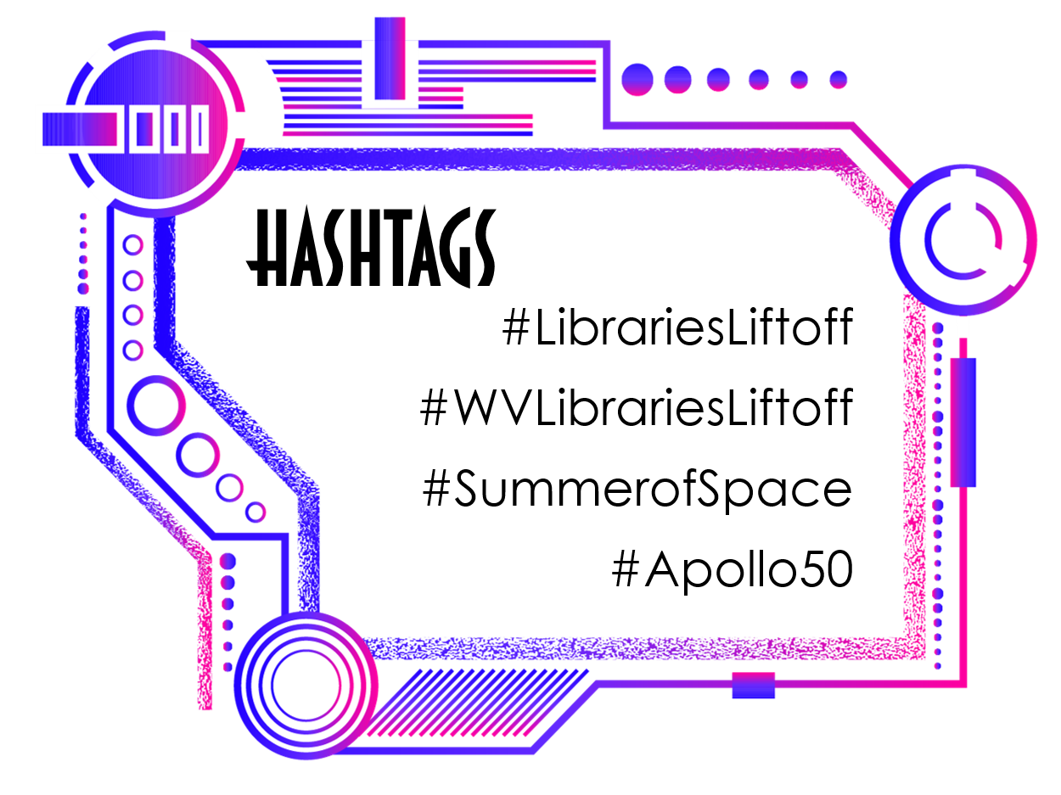
This summer celebrate the 50th anniversary of Earthlings on the moon! Discover A Universe of Stories at the library. #WVLibrariesLiftoff #LibrariesLiftoff

Find the whole Universe at your fingertips in the library. Join us for out of this world fun all summer. #WVLibrariesLiftoff #LibrariesLiftoff

Take me to your Reader! #WVLibrariesLiftoff #LibrariesLiftoff #SummerofSpace

To the Library… and beyond! #WVLibrariesLiftoff #LibrariesLiftoff #SummerofSpace

MEDIA Tips

Use a catchy email subject line since that is the first part a reporter will see.
Write something that carries weight but don’t oversell yourself.
We have a great summer reading program lined up this year. vs Local kids build cardboard Mars Rovers at the library.

Use timely events to promote your events.
July 20, 2019 is the 50th anniversary of the Apollo 11 moon landing… right in the middle of summer reading!

Be a resource for reporters for other news stories. Explain how the library can help with research and other areas of expertise for the community.

Research the best person to send your information to and develop a personal connection with the reporter.
Stay in contact but don’t make yourself a pest.

Keep up with changes at the local media outlets.

Use HARO: Help A Reporter Out https://www.helpareporter.com/

Send a copy of your newsletter or media kit to reporters along with a business card.

Send the reporter a handwritten thank you note after s/he covers the event.

